**AGGARWAL COLLEGE BALLABGARH**

**Class-B.C.A.-1st Semester**

**(Acc. to NEP 2020 BCA Ist Year)**

**Fundamentals of Computing and Problem Solving using C Lab Assignments**

**WEEK -1**

1. WAP to find factorial of a number

2. WAP to check whether number is Perfect square or not

3. WAP to find SUM and AVERAGE of two numbers

**WEEK-2**

4. WAP to convert temperature from Fahrenheit to Celsius and Celsius to Fahrenheit

5. WAP to read and print an employee's detail using structure

6. WAP to convert number from Decimal to Binary

**WEEK-3**

7. WAP to check whether number is Palindrome or not

8. WAP to print "Hello World".

9. WAP to swap two numbers without using third variable.

10. WAP to check whether a number if Armstrong or not.

11. WAP to check whether a number if Even or Odd.

**WEEK-4**

12. WAP to print all leap years from 1 to N.

13. WAP to calculate employee gross salary.

14. WAP to print tables of numbers from 1 to 20.

15. WAP to print star/pyramid series.

16. WAP to convert temperature from Celsius to Fahrenheit and vice versa.

**WEEK-5**

17. WAP to convert number from Decimal to Binary.

18. WAP to convert number from Binary to Decimal.

19. WAP to print ASCII Table.

20. WAP to get and set current system date and time.

**WEEK-6**

21. WAP to run dos command.

22. WAP to check whether a given number is palindrome or not using Bitwise Operator

23. WAP to count number of bits set to 1 in an Integer

24. WAP to check if all the bits of a given integer is one (1)

25. WAP to find the Highest Bit Set for any given Integer

**WEEK-7**

26. WAP to Count the Number of Trailing Zeroes in an Integer

27. WAP to find the Biggest Number in an Array of Numbers using Recursion

28. WAP to accept Sorted Array and do Search using Binary Search

29. WAP to Cyclically Permute the Elements of an Array

30. WAP to print the sum and product of digits of an integer.

**WEEK-8**

31. WAP to reverse a number.

32. WAP to compute the sum of the first n terms of the following series

S = 1+1/2+1/3+1/4+......

33. WAP to compute the sum of the first n terms of the following series

S =1-2+3-4+5................

34. Write a function that checks whether a given string is Palindrome or not. Use this function to find whether the string entered by user is Palindrome or not.

35. Write a function to find whether a given no. is prime or not. Use the same to generate the prime numbers less than 100.

36. WAP to compute the factors of a given number.

**WEEK-9**

37. Write a macro that swaps two numbers. WAP to use it.

38. WAP to print a triangle of stars as follows (take number of lines from user):

*

***

*****

*******

*********

39. WAP to perform following actions on an array entered by the user:

1. Print the even-valued elements
2. Print the odd-valued elements
3. Calculate and print the sum and average of the elements of array
4. Print the maximum and minimum element of array
5. Remove the duplicates from the array
6. Print the array in reverse order

The program should present a menu to the user and ask for one of the options. The menu should also include options to re-enter array and to quit the program.

40. WAP that prints a table indicating the number of occurrences of each alphabet in the text entered as command line arguments.

**WEEK-10**

41. Write a program that swaps two numbers using pointers.

42. Write a program in which a function is passed address of two variables and then alter its contents.

43. Write a program which takes the radius of a circle as input from the user, passes it to another function that computes the area and the circumference of the circle and displays the value of area and circumference from the main() function.

**WEEK-11**

44. Write a program to find sum of n elements entered by the user. To write this program, allocate memory dynamically using malloc() / calloc() functions or new operator.

45. Write a menu driven program to perform following operations on strings:

a. Show address of each character in string

b. Concatenate two strings without using strcat function.

c. Concatenate two strings using strcat function.

d. Compare two strings

e. Calculate length of the string (use pointers)

f. Convert all lowercase characters to uppercase

g. Convert all uppercase characters to lowercase

h. Calculate number of vowels

i. Reverse the string

46. Given two ordered arrays of integers, write a program to merge the two-arrays to get an ordered array.

**WEEK-12**

47. WAP to display Fibonacci series (i) using recursion, (ii) using iteration

48. WAP to calculate Factorial of a number (i) using recursion, (ii) using iteration

49. WAP to calculate GCD of two numbers (i) with recursion (ii) without recursion.

50. WAP to design calculator with basic operations using switch.

**AGGARWAL COLLEGE BALLABGARH**

**Class-B.C.A.-Ist semester**

**(Acc. to NEP 2020 BCA Ist Year)**

**Internet and Web Design Lab Assignment**

**Week-1**

1. Write HTML code to display your education details in a tabular format.

2. Write HTML code to display your CV on a web page.

**Week-2**

3. Write HTML code to create a Home page having three links: About Us, Our Services and Contact Us. Create separate web pages for the three links.

**Week-3**

4. Write HTML code to create a login form. On submitting the form, the user should get navigated to a profile page.

5. Write HTML code to create a Registration Form. On submitting the form, the user should be asked to login with new credentials.

**Week-4**

6. Write HTML code to create your Institute website, Department Website and Tutorial website for

**Week-5**

7. Write HTML code to illustrate the usage of the following:

8. Create the following: Ordered List, Unordered List and Definition List

**Week-6**

9. Write HTML code to create a frameset having header, navigation and content sections.

10. Write HTML code to demonstrate the usage of inline CSS.

**Week-7**

11. Write HTML code to demonstrate the usage of internal CSS.

**Week-8**

12. Write HTML code to demonstrate the usage of external CSS.

**Week-9**

13. Write HTML program to create a webpage to show different art forms of India, with appropriate title on the title bar. Use different heading tags for the headings, and list them using ordered list.

**Week-10**

14. Write HTML program to create sections in the document using appropriate tags and apply different color as background to them. Use internal hyperlinks to move to different points within the page.

**Week-11**

15. Write HTML program to insert a picture on the webpage, giving description for the picture in a paragraph. Use properties of height, width, hspace, vspace and align, with different values.

**Week-12**

16. Write HTML Program, to create a profile of 2 pages, the First page containing the applicant’s picture with personal details using unordered lists, and the second containing Educational details using tables. Use hyperlinks to move to the next page.

**AGGARWAL COLLEGE BALLABGARH**

**Acc. to NEP 2020 BCA Ist Year)**

**Class-B.C.A.-2nd Sem**

**Data and File Structure, Web Development**

**WEEK -1**

* Write a program to Insert, delete, and search elements in an array.
* Write a program to find the largest and smallest elements in an array.
* Write a program to reverse an array.
* Write a program to merge two sorted arrays.

**WEEK -2**

* Write a program to implement a **Singly Linked List** (Insertion, Deletion, and Display).
* Write a program to implement a **Doubly Linked List**.
* Write a program to implement a **Circular Linked List**.
* Write a program to Implement Reverse a Linked List.

**WEEK -3**

* Write a program to Implement push, pop, and peek operations.
* Write a program to convert an infix expression to postfix.
* Write a program to evaluate a postfix expression.
* Write a program to Check for balanced parentheses using a stack.

**WEEK -4**

* Write a program to implement a simple queue (Enqueue & Dequeue operations).
* Write a program Implement a circular queue.
* Write a program Implement a priority queue.

**WEEK -5**

* Write a program to implement **Bubble Sort**.
* Write a program to implement **Selection Sort**.
* Write a program to implement **Insertion Sort**.
* Write a program to implement **Merge Sort**.
* Write a program to implement **Quick Sort**.

**WEEK -6**

* Write a program to implement **Binary Search Tree (BST)** (Insertion, Deletion, and Traversal).
* Write a program to implement **Depth First Search (DFS)**.
* Write a program to implement **Breadth First Search (BFS)**.
* Write a program to implement **Linear Search**.
* Write a program to implement **Binary Search**.

**WEEK-7**

* Write a program to implement HTML page using javaScript to load and display XML

**WEEK-8**

* Write a program to implement create an XML file and XSLT stylesheet to transform XML data into HTML table

**WEEK-9**

* Write a program to implement parse XML data with javascript and display employee names and departments in a list on web pages.
* Write a program to implement develop a form that Develop a form that allows users to subinit their contact information (name, email, message); Use AJAX send the form data to a server-side script (eg. a PHP script) that echoes the received dans Display the

**WEEK-10**

* Write a program to implement Write an Ajax script to get player details from sml file when user select player name in any game. Also create xml file to store details of playeriname, country, wickets and runs)
* Write an AJAX request to a URL that does not exist Implement error hardling to display a user-fhendly message when the request fails

**WEEK-11**

* Write a jQuery code to select values from a JSONobject. Also Write a Query code to remove all CSS
* Create a PHP script that defines variables of differens data types (string, integer, float, boolean, array).

**WEEK-12**

* Develop an HTML form to upload a file. Write a PHP script to handle the file upload, save the file on the
* Create a MySQL database and table to store user information (name, email). Write a PHP script to connect to the database and insert a new user record. Display a success message upon successful insertion
* Create a web page for Travel agency using PHP.

**AGGARWAL COLLEGE BALLABGARH**

**Class-B.C.A.-3rd sem**

**Subject-SQL Commands, Data Structures**

Week-1

Create a table

Table name—Table 1

Column name- Emp_no, Emp_name, Salary, Address

No. of rows-10

Week-2

1.Show al record in table 1

2. Find al employee number,emp_name from Table1

3. Select all employees whose salary >10000

4. Select emp_no. emp_name who are living in Faridabad

Week-3

1. Add new column in table 1 having column name -Designation
2. Fill all records in designation column

Week-4

1. Show al typoe of Designations in Table 1( Distinct)
2. Show all records according to name in ascending and descending order(A-Z)

Week-5

1. Creating a new Table from Table1
2. Inserting data into a new table from table1

Week-6

1. Delete Record from Table1 whose employee number is 0010
2. Change the address in Table1 from FBD to Faridabad
3. change the table name from Table1 to Employee .
4. Draw new table.

Week-7

1. Use primary, foreign, Unique, Not nul constraint in Employee table

Week-8

1. Use Arithmetic and Logical in Employee table

Week-9

1. Select all employees name whose name start by A in Employee table (Like, , %, _)

Week-10

1. Use all aggregate functions in Employee table
2. Use all Scalar Functions with dual table

Week- 11 to 14

Create a mini Project based on oracle

**Assignment**

**Data Structure -I**

**Week 1:**

Q1) Write a C program that prints below shape of triangle using nested loop

*****

****

***

**

*

Q2) Write a C program that prints below shape of rectangle using nested loop

*********

*********

*********

*********

*********

Q3) Write a C program that prints below shape using nested loop

*

**

***

****

*****

*****

****

***

**

*

**Week 2:**

Q4) Write a program to implement Linear Array with insertion and Deletion Operations

Q5) Write a program to find the smallest number from an Array.

Q6) Write a program to find the biggest number from an array.

**Week 3:**

Q7) Write a program to convert Decimal number to its equivalent Binary number.

Q8) Write a program to find transpose of an array of order m x n.

Q9) Write a program to find the first and second largest number of an array.

**Week 4:**

Q10) Write a program to Arrange Array elements in Ascending order.

Q11) Write a program to Marge two linear arrays.

Q12) Write a program to reverse array elements

**Week 5:**

Q13) Write a program to read a line of text using getchar function.

Q14) Write a program to read and write multiple lines of characters using arbitrary character to end inputting.

Q15) Write a program to reverse a given string.

**Week 6:**

Q16) Write a program to conut the number of characters, words and lines in a text.

Q17) Write a program to check weather a given string is a palindrome or not.

Q18) Write a program to convert a string to uppercase.

**Week 7:**

Q19) Write a program to implement 2D Array.

Q20) Write a program to Add Two 2D Arrays.

Q21) Write a program to find Multiplication of two 2D Arrays.

**Week 8:**

Q22) Write a program to implement stack using array. Use functions to write Push and Pop operations of stack.

Q23) Write a program to calculate factorial of a given number.

**Week 9:**

Q24 ) Write a program to convert an infix expression in to prefix expression.

Q25) Write a program to convert an infix expression in to postfix expression.

Q26) Write a program to convert postfix expression in to infix expression.

**Week 10:**

Q27) Write a program to implement Queue using array . Use functions to write insertion and deletion operations.

Q28 ) Write a program to implement Circular Queue.

**Week 11:**

Q29 ) Write a program to implement linear linked list using pointers.

Q30 ) Write a program to implement Circular linked list using pointers.

**Week 12:**

Q31 ) Write a program to implement Doubly linked list using pointers.

Q32) Write a program to implement Stack Using linear linked list .

Q33) Write a program to implement Queue Using linear linked list.

**AGGARWAL COLLEGE BALLABGARH**

**Class-B.C.A.-4th sem**

**Subject-HTML, C++**

**WEEK 1**

1. Apply formatting tags(bold, italic ,underline) on the below paragraph:-
2. Apply paragraph tags (<p>),break tag(<br>)on below paragraph:-
3. Give title and heading to your documents.(title=First program of H TML, heading= My first program).

A history of every thing

It start with a bang. Then everything inflates like a super balloon tieds up with super-strings, until the whole mess curdles into millions of milky ways. Starlight hits the volcanic rocks, and cooks up some tasty double-helix treats. They get eaten by each other, the fittest survive, a meteor kills the big ones and when it all freezes over the smart ones move into caves and start a fire

Wonders of the World

Vacations are not cheap. But who needs them anymore, with so many live cameras connected to the World Wide Web? Pack a picnic, and you can visit spacious pastures in allowed, New Jersey or the more scientifically minded at IBM’s Alma den Research Center. Or if it’s scenery you’re after adventure to ta half payer backyard in Fremont California.

**Week 2**

1. Apply heading tags(h1,h2,h3,h4,h5.h6) on the following line:

I love my India I am proud on my India.

1. Change font face, color ,size , alignments on the above paragraph:-
2. Apply <pre> tag on the marks of 5 student in a following format:-

Stud roll stud name sub1 sub2 sub3 sub4 sub5 total %age

**Week 3**

1. Apply Definitions are indented with respect to the terms.

banana

a tropical yellow fruit

apple

one a day keeps the doctor away

lemon

basis of lemonade

2. Insert an image by using suitable path of the image on your html documents like:-

<IMG SRC="protocol://server:port/path/filename.ext" WIDTH="#" HEIGHT="#">

**Week 4**

1. Create order and unordered list by using html tags on the below elements:-

* Vehicals

1. Two wheelers

Bike

Bicycle

* Companies of two wheelers

1. Three wheelere

* Auto
* Companies of three wheelers

1. Four wheelers

* Car
* Companies of four wheelers

You should create more than that list like fruits, electrical equipment’s etc. and add at least five entries in each part of list.

2. Make a documents by using <small>,<big>,<sup>,<sub> , <strike>, <strong> tags on the following paragraph:-

**New**super**strength** H2O plus will ~~strike out~~ any stain, big or small. Look for new super **strength** H2O *plus* in a stream near you.

**Week 5**

1. Insert an background image and color on your document by using the following tag:-

<body background=”filename or URL”>

1. Apply marquee tag on the following points:-

1. Make a conference alert

2. Make an admission alert (form date ,submission date, last date of submission of the form).

3. Any breaking news flash about your document.

4. Fresh results announcements and give an link page.

5. New roll no. Issue to the students of BCA class .

Also give an alignment like up, down, left or right.

**Week 6**

1. Create link from one page from another by the following code on the all **above** marquee alerts:-

<a href=”filename.html”>admission alert symbol</a>

**Week 7**

1.**create a table according to BASIC TABLE**

This table:

|  |  |  |  |
| --- | --- | --- | --- |
| Row 1, Col.1 | Col. 2 | Col. 3 | Col. 4 |
| Row 2 | aaa | bbb | Ccc |
| Row 3 | ddd | eee | Fff |

Is produced by this code:

<TABLE BORDER="1" CELLPADDING="4" CELLSPACING="0" BGCOLOR="#FFFF66">  
<TR><TH>Row 1, Col.1</TH><TH>Col. 2</TH><TH>Col. 3</TH><TH>Col. 4</TH></TR>  
<TR><TD>Row 2</TD><TD>aaa</TD><TD>bbb</TD><TD>ccc</TD></TR>  
<TR><TD>Row 3</TD><TD>ddd</TD><TD>eee</TD><TD>fff</TD></TR>  
</TABLE>

where:

|  |  |
| --- | --- |
| <TABLE> starts the table | </TABLE> ends the table |
| <TR> starts a row | </TR> ends a row |
| <TH> makes a column header | </TH> ends a column header |
| <TD> starts a column | </TD> ends a column |

By default:

* a column header, <TH>, is displayed in bold and centered
* a regular cell entry, <TD>, is left aligned and in plain text, and
* the contents of cells in a row will be aligned vertically to the middle of the row from top to bottom.

### Create atleast 10 rows and 10 columns in a table and make two tables as results of the students and a table of employees (at least 10 records in each table).

Note:- use alignment in tables like center, left or right.

**Week 8**

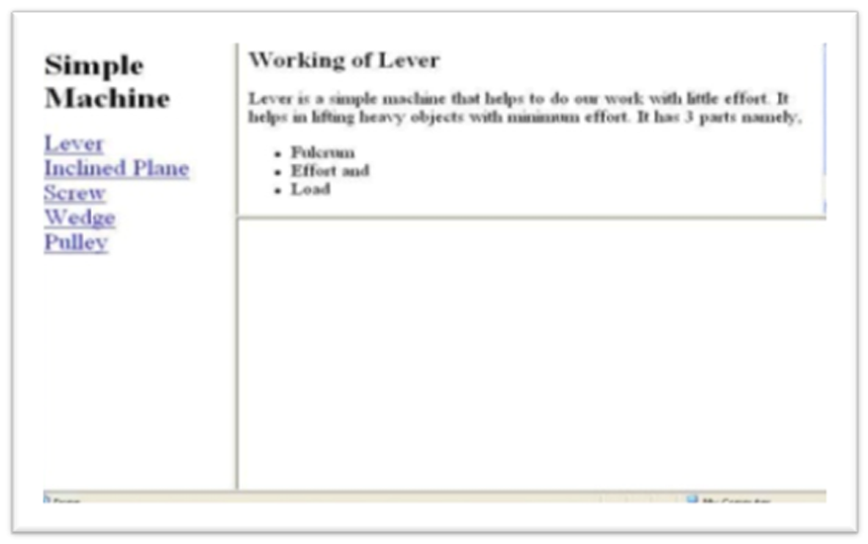

1. Make frames on your document as per the above image.

**Week 9**

1. Make admission form for college, job description form .

**Week 10**

1. Make website on one of the following or as per your choice topics:
2. Solar system
3. Hospital management system
4. Library management system
5. Hotel management
6. Flight reservation system
7. Bank
8. Departmental store
9. Railway reservation
10. Incredible india
11. Customer care system on any of “ e based system.

**Week 11-12**

1. Preparing of web site and revision of various tags.

**C++**

**WEEK -1**

1. WAP to calculate the compound interest for the entered value of principal, period and rate.
2. WAP to print the following output

1

2 2

3 3 3

4 4 4 4

5 5 5 5 5

1. WAP to calculate the root of a quadratic equation.

2x2 + 4x +15

**WEEK -2**

1. WAP to represent a Prime no. series

1 2 3 5 7 11 13 ………

1. WAP to display Fibonacci series upto entered n numbers.
2. WAP to find the largest among entered n numbers.

12,34,55,0,11,77,100,2,4,5

**WEEK -3**

1. WAP to calculate the multiplication of two matrices.

2 5 6 4 7 8

4 7 3 * 2 6 0

2 5 2 0 1 5

1. WAP to calculate the addition of above two matrices.
2. WAP for implementing an inline function .

**WEEK -4**

1. WAP for illustrating scope resolution operator.
2. Write a function power() to raise a number m to a power n. The function takes a double value for m and int value for n and returns the result correctly. Use a default value of 2 for n. write a main that gets the values of m and n from the user.
3. WAP for implementing friend function using two classes.

**WEEK -5**

1. WAP for using object as function arguments(e.g. adding hours and minute in the class time)
2. WAP for returning objects as addition of two Complex numbers.

4+5i and 7+9i

1. Define a class to represent a bank account. Include the following members:

Data members

1. Name of depositor
2. Account number
3. Type of account
4. Balance amount in the account

Member functions

1. To assign the initial values.
2. To deposit an amount.
3. To withdraw an amount after checking the balance.
4. To display name and balance.

**WEEK -6**

1. WAP for implementing a constructor.
2. WAP for implementing all types of constructor.
3. WAP for dynamic initialization of constructor.
4. WAP for implementing destructor.

**WEEK-7**

1. WAP for unary minus operator overloading.
2. WAP for binary operator overloading.
3. WAP for overloading of operator using friend function.

**WEEK -8**

1. WAP for implementing single inheritance.
2. WAP for implementing multilevel inheritance.
3. WAP for implementing multiple inheritance.
4. WAP for implementing hybrid inheritance.

**WEEK -9**

1. WAP for implementing the concept for virtual base class.
2. WAP for deriving constructor in the derived class.
3. WAP for implementing virtual functions.

**WEEK -10**

1. WAP for illustrating the use of THIS pointer.
2. WAP for illustrating pointer to object.
3. WAP for array of pointer to object.
4. WAP for pointer to derived object.

**WEEK -11**

1. WAP for implementing compile time polymorphism.
2. WAP for implementing run time polymorphism.
3. WAP for working with multiple files.

**WEEK -12**

1. WAP for working with class template.
2. WAP for working with function template.
3. WAP for function template with multiple parameter.
4. WAP for member function template.

**WEEK -13**

1. WAP for exceptional handling by try catch and throw statement.
2. WAP for implementing multiple catch statement.
3. WAP for implementing rethrowing an Exception.

**WEEK -14**

For revision and Practical file.

**AGGARWAL COLLEGE BALLABGARH**

**Class-B.C.A.-5th sem**

**Subject- Graphics, Visual Basic**

COMPUTER GRAPHICS

WEEK1:

Create a menu driven program to draw Line, circle, Ellipse, rectangle, Square.

WEEK2:

W.A.P. to draw HUT.

WEEK3:

W.A.P. to draw STAR.

WEEK4:

W.A.P. for Natural scene with moving bird.

WEEK5:

W.A.P. for solar system.

WEEK6:

W.A.P. to for clock

WEEK7:

W.A.P. to for concentric circles

WEEK8:

W.A.P. for Blinking circles

WEEK9:

W.A.P. for flying kite

WEEK10:

W.A.P. for generating different line styles on screen

WEEK11:

W.A.P. for making light house

W.A.P. to draw flag

WEEK12:

W.A.P. for moving ball

**ASSIGNMENT ON VB**

**WEEK 1**

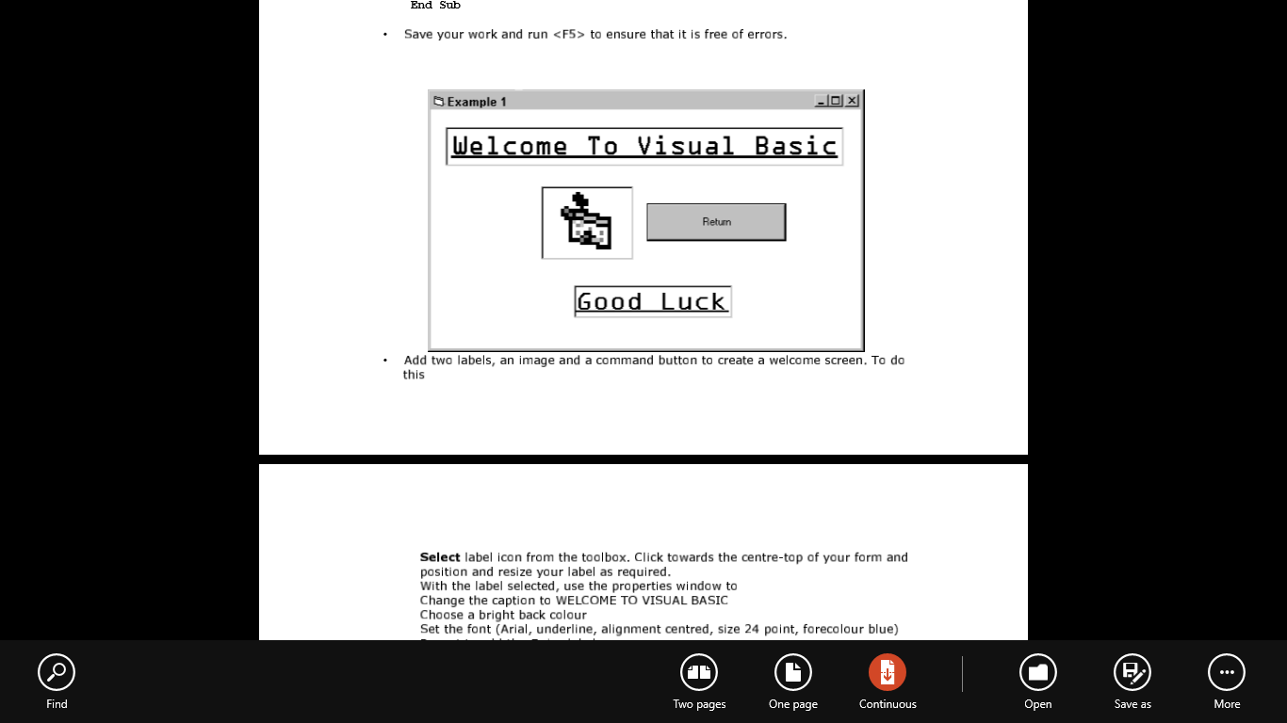

* Use the properties window to set

– M a i n f r am a s t h e f o r m n a m e .

– M y p r o g r a m s a st h e c a p t i o n .

– B a c k C o l o r t o W h i t e .

– B o r d e r S t y l e t o F i x e d S i n g l e .

– W i n d o w S t a t e t o M a x i m i s e d .

* Find the Menu icon and click on it to select it. Enter the following menu headings: Quit Introduction with indented subheadings of

Example 1

Click on Quit menu heading and enter the following code. This procedure is used to exit from running the project display and return to the design screens.

Private Sub Quit_Click()

Unload me

End Sub

Week 2

* Use the <F5> function key to run the application to verify that the Menu structure is correct and that the Quit procedure is free from error.

**Set the following form properties:**

1. form name as Welcome caption to Example1
2. BackColor to White
3. BorderStyle to Fixed Single
4. WindowState to Maximised

* Click on the Example 1 main menu heading and enter the following code:

Private Sub Example1_Click()

Welcome.Show

End Sub

* Save your work and run <F5> to ensure that it is free of errors.
* Add two labels, an image and a command button to create a welcome screen.
* Select label icon from the toolbox. Click towards the centre-top of your form and position and resize your label as required.

With the label selected, use the properties window to

1. Change the caption to WELCOME TO VISUAL BASIC
2. Choose a bright back colour
3. Set the font (Arial, underline, alignment centred, size 24 point, forecolour blue)
4. Repeat to add the Enjoy label.
5. Use the image icon on your toolbox to add the image to your form. Use the
6. properties window of the image to select a picture.

* Use the file menu to save your work and use <F5> to run the application.
* DON’T FORGET TO SAVE (AND BACK UP TO FLOPPY) ALL YOUR WORK.

WEEk 3

* Op e n a n e w f o r m a n d c h a n g e i t sn a m e t o C o l o u r C h a n g e r . P l a c e t h e f o l l o w i n g o b j e c t s on this form.

1. A heading label2 (Caption = Colour Changer)
2. 3 horizontal scroll bars (Set the max value property of all three to 255)
3. 3 other labels (2red, 3Green, 4Blue)
4. a command button to quit the form (Caption = Return)
5. another small label5 under the button with its visible property set to false.

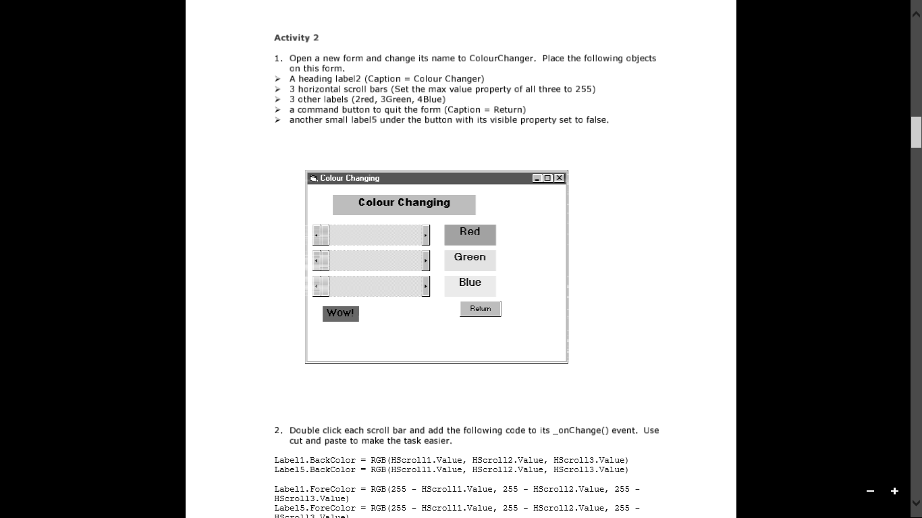

* D o u b l e c l i c k e a c h s c r o l l b a r a n d a d d t h e f o l l o w i n g c o d e t o i t s _ o n

C h a n g e ( ) e v e n t . U s e

cut and paste to make the task easier.

1. Label1.BackColor = RGB(HScroll1.Value, HScroll2.Value, HScroll3.Value)
2. Label5.BackColor = RGB(HScroll1.Value, HScroll2.Value, HScroll3.Value)
3. Label1.ForeColor = RGB(255 - HScroll1.Value, 255 - HScroll2.Value, 255 - HScroll3.Value)
4. Label5.ForeColor = RGB(255 - HScroll1.Value, 255 - HScroll2.Value, 255 - HScroll3.Value)
5. Label5.Visible = True Label5.Caption = “WOW!”
6. Label2.BackColor = RGB(HScroll1.Value, 0, 0) Label3.BackColor = RGB(0, HScroll2.Value, 0)
7. Label4.BackColor = RGB)0, 0, HScroll3.Value)

* D o u b l ec l i c k t h er e t u r n b u t to n a n d a d d t h e f o l l o w i n g c o d e t o i t s _ o n C l i c k ( ) e v e n t

Unload Me

WEEK 4

function is a segment of code that accepts zero, one or more arguments and returns a single result. Visual Basic includes many built-in functions (intrinsic functions). Some perform basic mathematical tasks. Others manipulate string data such as converting text to upper Case or lower Case letters. An argument is a value you pass to a function so the function has data to work with. Function names have parentheses at the end to hold the function arguments. Even if a function has no arguments, the parenthesis are required.

Two intrinsic functions include message boxes and input boxes.

Message and input boxes

Message and input boxes are intrinsic functions in Visual Basic 6.0 which allow the end user to interact with the program. Follow the instructions Add new form to menu at the end of Week 1 to create a new form with a menu heading on the main form.

Call this “Message and Input Boxes”

* Make the Form.Caption = “Message and Input Boxes”
* Put a label on the top of the form “Computer Conversation”. Underneath have a

command button with the caption “Talk to me!” Name the command button cmdTalk.

* Double click the command button to add the following code sequence.

Private Sub cmdTalk_Click()

Dim strQuestion As String

Dim intAnswer As Integer

‘First you must declare your variables’

‘Then use the input and message box functions’

strQuestion = InputBox(“Type in your name!”, “Ebeneezer”) intAnswer = MsgBox(“Hello there” &strQuestion, vbOKCancel, “Chat”)

End Sub

* Add a return button, called cmdBack as you did in the ColourChanger, using the code

Private Sub cmdBack_Click()

Form1.Show

End Sub

* Run your program using <F5>. Don’t forget to save your work. Here are some handy literals (values that don’t change). You don’t have to learn them as the help prompt supplies a drop down list as you start to type.

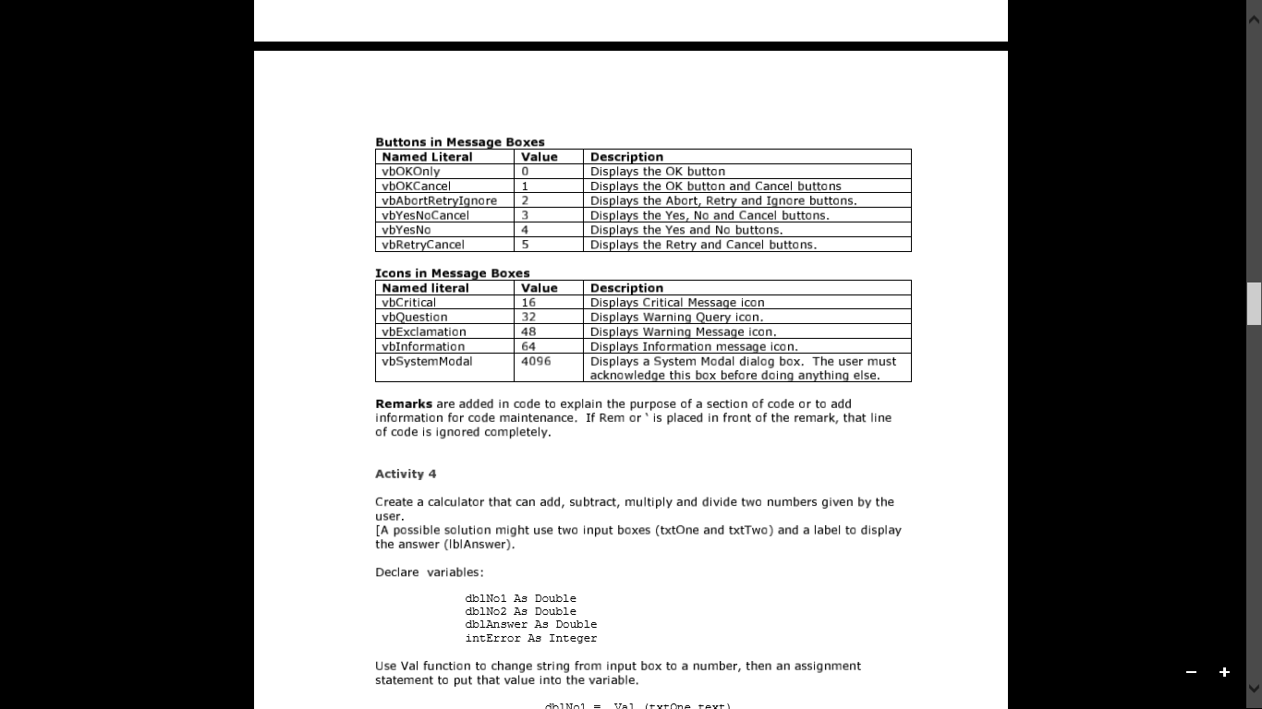

**WEEK 5**

Create a calculator that can add, subtract, multiply and divide two numbers given by the user.

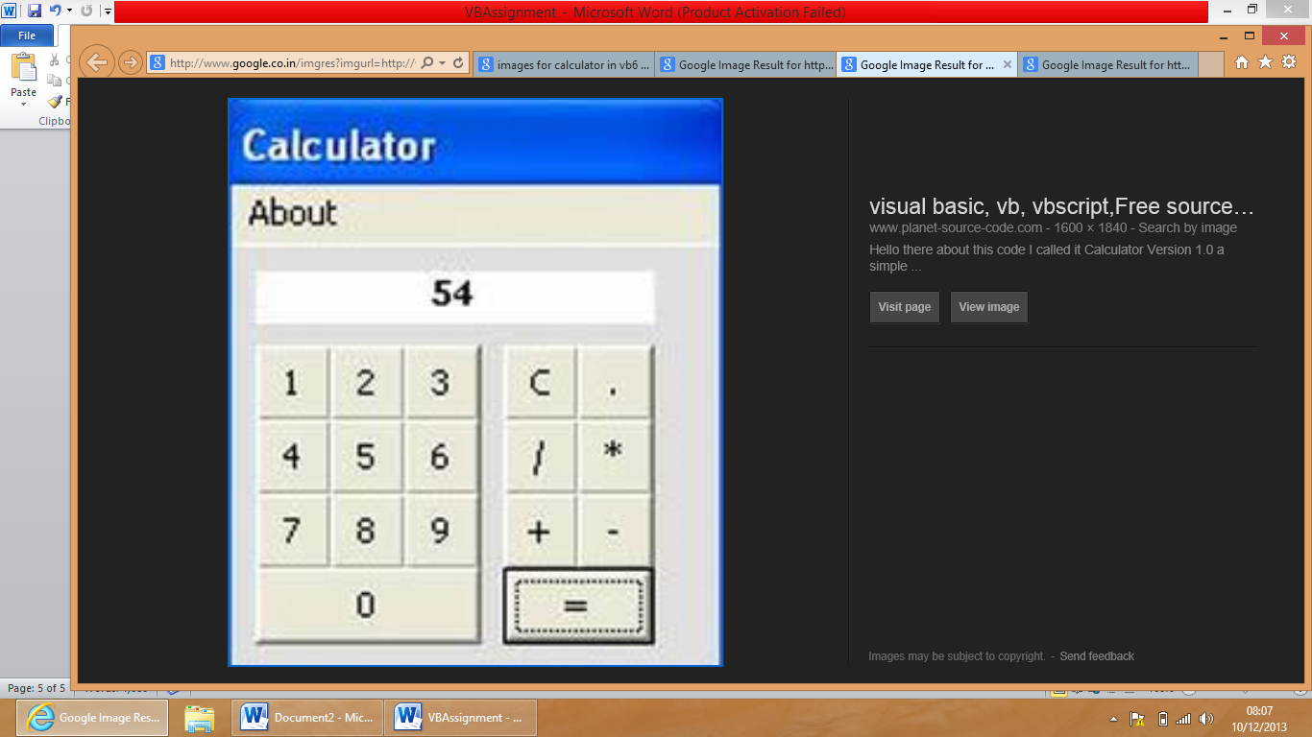

**WEEK 6**

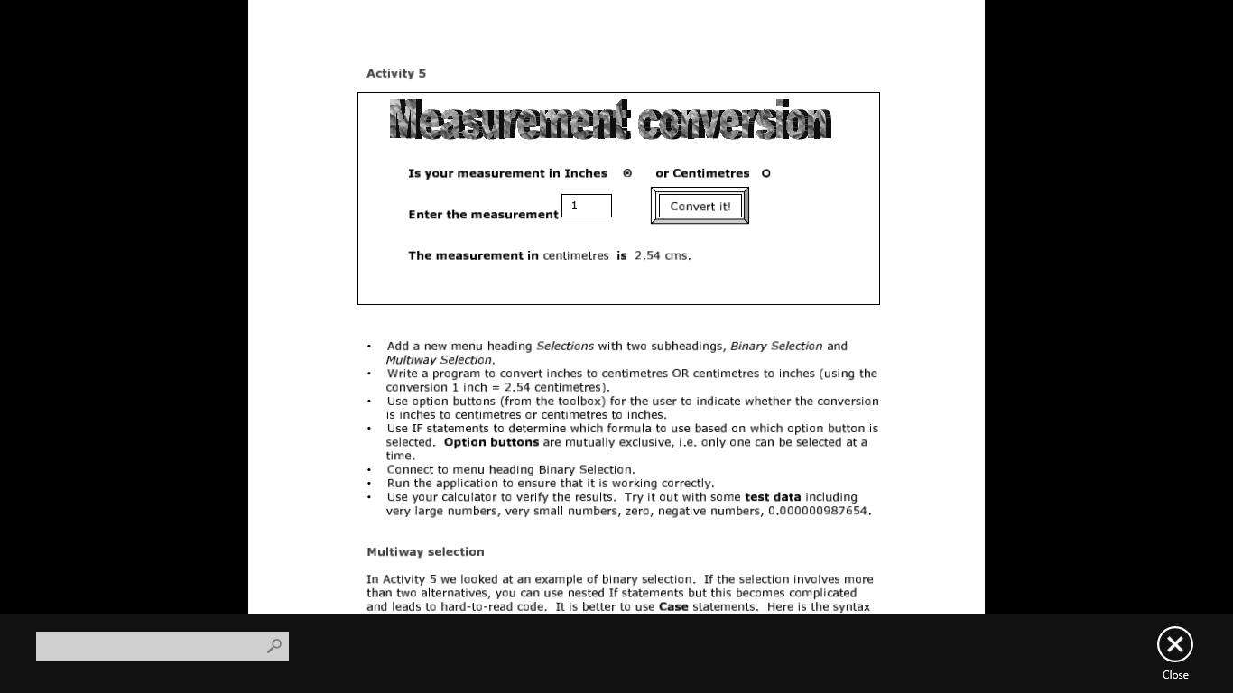

* Write a program to convert inches to centimetres OR centimetres to inches (using the conversion 1 inch = 2.54 centimetres).
* Use option buttons (from the toolbox) for the user to indicate whether the conversion is inches to centimetres or centimetres to inches.
* Use IF statements to determine which formula to use based on which option button is selected. Option buttons are mutually exclusive, i.e. only one can be selected at a time.

**WEEK 7**

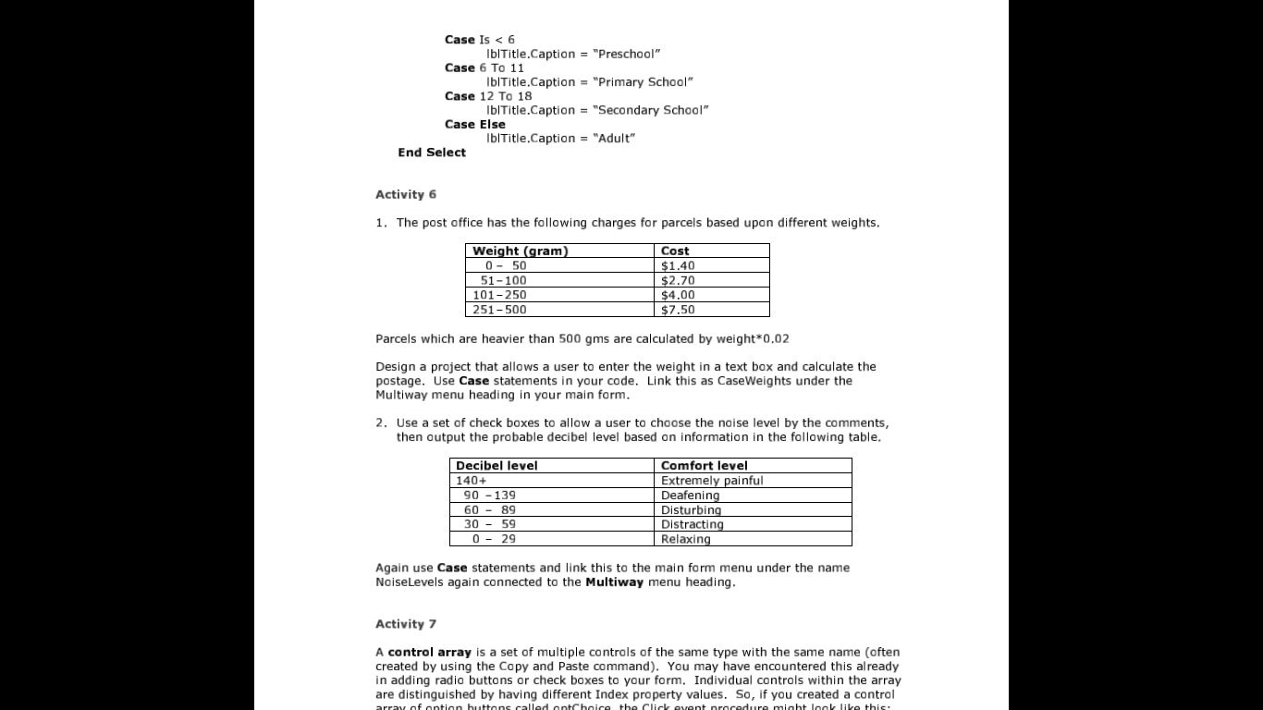

Design a project that allows a user to enter the weight in a text box and calculate the postage. Use Case statements in your code. Link this as CaseWeights under the Multiway menu heading in your main form.

**WEEK 8**

Create a program to generate the first 20 Fibonacci numbers. This time use a counter to control the number of iterations. By using For Loop, Do While Loop, While Loop.

**WEEK 9**

Writean event procedure to perform the following in vb:

* Reverse a string
* Determine whether the given string is palindrome
* Change the case of a string to upper or lower.

**WEEK 10**

Create a menu with the following menu optins:

* Style(which includes bold, italic and underline)
* Colour (which includes blue, green and red)
* Change Case (which includes uppercase, lowercase).

**WEEK 11-12**

Write a VB program to create a product table and to perform the following database operation :

* Insert the records
* Delete the records
* Update the records

**AGGARWAL COLLEGE BALLABGARH**

**Class-B.C.A.-6th sem**

**Subject- Java Programming**

**JAVA ASSIGNMENT**

**Week-1**

1. Write a simple java program to print “Hello” word on the screen.
2. Write a simple command line argument program.
3. W.A.P swapping of two number.

**Week-2**

1. W.A.P to compute the area of circle.
2. W.A.P to find the perimeter & square.
3. W.A.P to generate this output

*

* *

* * *

* * * *

* * * * *

**Week-3**

7. W.A.P to generate this output

0

1 2

3 4 5

1. 7 8 9
2. W.A.P to print this output

1

2 2

3 3 3

4 4 4 4

1. W.A.P to calculate the sum of digit of a given number.

**Week-4**

1. W.A.P to calculate the Fibonacci series using do while.
2. W.A.P to display volume of a Box.
3. W.A. Simple Constructor program.

**Week-5**

1. W.A.P of parameterized constructor.
2. W.A.P of Method overriding
3. W.A.P of Method overloading.

**Week-6**

1. W.A.P to show use of Abstract class.
2. W.A.P of single inheritance.
3. W.A.P of multiple inheritance.

**Week-7**

1. W.A.P of hierarchical inheritance.
2. W.A.P to create a single interface.
3. W.A.P to create your own package.

**Week-8**

1. W.A.P of Exception Handling.
2. W.A.P to show multiple catch block.
3. W.A.P to show multiple try block.

**Week-9**

1. W.A.P to show use of exception handling with finally method.
2. W.A.P to show use of a string
3. W.A.P to show use of a string buffer.

**Week-10**

1. W.A.P to show use of a vector class.
2. W.A.P to show multi threading.
3. W.A.P to show use of simple applet.

**Week-11**

1. W.A.P to draw a hut using applet with graphics.
2. W.A.P to draw a human face using applet with graphics.
3. W.A.P to draw a light house using applet with graphics.

**Week-12**

1. W.A.P to read a file.
2. W.A.P to write a file.
3. W.A.P to reverse of already exist file.
4. W.A.P to accept a no. from used and count the no. of digits.
5. W.A.P check no. is Armstrong or not.

**AGGARWAL COLLEGE BALLABGARH**

**Class-B.C.A.-6th sem**

DotNet

WEEK 1:

* Create a console based application to display output on the screen.
* Create a console based application to accept input from user.
* Create a console based application to accept command line arguments from user.

WEEK 2:

* Create a console based application to accept student detail(student name, roll no) at command line and display them on screen.
* Write a program to generate a window form with a simple message.

WEEK 3:

* Write a program to generate a series of first 50 even numbers.
* Write a program to generate a FIBONACCI series .
  + 0, 1, 1, 2, 3, 5, 8, 13, 21
* Write a program to generate tables from 2 to 20 with first 10 terms .
* Write a program to find the greastest among three numbers.

WEEK 4:

* Write a program to find the average of n natural numbers using for loop.
* Write a program that inputs an integer – determine if it is even or odd (USING IF ELSE STATEMENT).
* Write a program to find the given year is a leap year or not.
* Write a program to find the area of a triangle using

Area= sqrt(s(s-a)(s-b)(s-c)), where s=(a+b+c)/2

WEEK 5:

* Write a program to create a structure.
* Create a structure with constructor.
* Write program for matrix multiplication using array.

WEEK 6:

* Write a program which calculate area of different shapes entered by user using switch case.
* Write a programwhich iterates over the elements of the string array using foreach loop.
* Execute the following program and recognise the output:

using System;

public class WhileLoopSample

{

public void RunForAwhile()

{

TimeSpan durationToRun = new TimeSpan(0, 0, 30);

DateTime start = DateTime.Now;

while (DateTime.Now - start < durationToRun)

{

Console.WriteLine("not finished yet");

}

Console.WriteLine("finished");

}

}

WEEK 7:

* Create a class which have attributes, methods, consturctor and finalizer and create its objects as reference type as well as value type.
* Write a program to create a string indexer that returns a string value.
* Write a program which have overloaded constructors.

WEEK 8:

* Write a program for handling exceptions.
* Wtrie a program to create nested namespaces.
* Write a program which have a static class.
* WAP for implementing single inheritance.

WEEK 9:

* WAP for implementing multilevel inheritance.
* WAP for implementing multiple inheritance.
* WAP for implementing hybrid inheritance.
* WAP for implementing the concept for virtual base class.
* WAP for deriving constructor in the derived class.
* WAP for implementing virtual functions.

WEEK 10:

* Write a program for reading a file.
* Write a program for writing in a file.
* Write a program to append the text in an existing file.
* Write a program to copy the data of one file to another.

WEEK 11:

* Write a program to create a window based application for making a student registration form.
* Write a program to create a text editor.

WEEK 12:

* Practical and Revision